**Name- *Prashant Walunj***

**roll no-183 (AIML)**

**REPORT**

***Automation Expo 2018***

**Title of visited project:**

Smart Home Automation System**.**

**Why I chose this project**

Once seen only a few decades ago as a completely futuristic idea is now being found in numerous homes, this is [**home automation system**](https://amzn.to/2m3zCGT) which is a fabulous, multi-feature monitor that utilizes the latest digital technology to help you keep track of a variety of home functions, all to make your life easier and safer.

The home automation market was worth US$5.77 billion in 2013, predicted to reach a market value of US$12.81 billion by the year 2020.

**Views on project:**

**Home automation** or **domotics**is [building automation](https://en.wikipedia.org/wiki/Building_automation) for a home, called a **smart home** or **smart house**. A home automation system will control lighting, climate, entertainment systems, and appliances. It may also include home security such as access control and alarm systems. When connected with the Internet, home devices are an important constituent of the [Internet of Things](https://en.wikipedia.org/wiki/Internet_of_Things).

A home automation system typically connects controlled devices to a central hub or "gateway"[[3]](https://en.wikipedia.org/wiki/Home_automation#cite_note-3). The [user interface](https://en.wikipedia.org/wiki/User_interface) for control of the system uses either wall-mounted terminals, tablet or desktop computers, a mobile phone application, or a Web interface, that may also be accessible off-site through the Internet.

While there are many competing vendors, there are very few worldwide accepted industry standards and the smart home space is heavily fragmented. Manufacturers often prevent independent implementations by withholding documentation and by litigation.

**Project 1:**

Smart Home Automation System

### All About ****Wretro****

Wretro is a brand solely owned and operated by RFzone Automations Pvt. Ltd. With an aim to make technology more accessible to all income groups, we at Wretro try to automate as many homes as possible. Our reasonably priced solutions make managing small tasks/ chores around the house a breeze.

Along with high end features and the simplicity of operation, Wretro can be accessed and monitored remotely, allowing you to have peace of mind at all times. We provide intelligent hardware and software to make life simpler. Unlike other solutions in the market that are used only for a single purpose, Wretro brings to the customer an amalgamation of machine-to-machine, IoT and smart systems. Empowering connection and control across digital and physical barriers along with harnessing the profound potential of the IoT through end-to-end services and advanced platforms.

Wretro transforms a house into a Smart Home. With a single touch, control all your electronic devices from your phone when you are at home, or outside.

Wretro also empowers you to operate all your appliances remotely.

Use our unique voice command feature to manage your home and more.

* Forgot to turn the lights off while leaving the house?
* Want your room to be cool before you reach home?
* Schedule your coffee machine to make piping hot coffee as soon as you get up?

**Live in future**  Make life easy with home automation

* **Control Everything with Your Fingertips** Turn on lights, play your favourite music or change your room temperature, just by tapping your smartphone.
* **Run Personalized Schedules** Have coffee ready when you wake up. Automatically turn everything off when you leave for work. Experience true intelligence.
* **Change Your Room Modes** Let mood reflect in your ambience.Change the room mode to experience a new atmosphere every time!

### Bring Home to life with ****Smart Automation****

Almost every electronic device and appliance in your house can be automated with wretro’s unique product portfolio, which can be managed through a remote control, mobile app or voice control. This helps our clients become energy efficient and environmentally proactive with the convenience and comfort of their homes.

## Live Simple **Live Smart**

* 

#### Remote Control

With the help of an exclusive RF technology . Wretro allows you to Control all your electronic devices with just one tab.

* 

#### Mobile App

Wretro App is available on Play Store and App Store. The App gives you the liberty to control your smart home from anywhere.

* 

#### Touch: Forget the Tick Tock

With Wretro Smart Touch Switches, Now touch to operate the devices, rather than pressing or pushing like normal switches. These switches are stylish, easy to install and operate.

* 

#### Schedule Appliances

Whether you need the curtains to open as soon as it is 7 am or want the geyser to start before you go for a shower. You name it and we do it for you. You can schedule your appliances as per your need and comfort.

* 

#### Ambient Lighting

Change the ambience of your house and workplace according to your mood. Be it party, meditation, work or family time, you can enjoy it by setting these modes on the remote control ,voice control or the Wretro App.

* 

#### Automated Door Locks

Now Lock or unlock your home and workplace with just a tab on your phone from anywhere.

**Scope of Project:**

The future would be of advanced sensors and artificial intelligence.

Till date home automation has been looked upon as something to only on/off your devices from mobile phone, but the scenario is changing rapidly, regular automation combined with smart wireless network of sensors started to understand the human environment. Sensors like motions sensor, temperature sensors, light intensity sensors, smoke detectors, humidity sensors etc. are being accommodated with home automation and the data from these sensors would further be used to analysed to understand use patterns and in-turn with deep learning used for the intelligence of the device itself.

**Photographs with caption:**

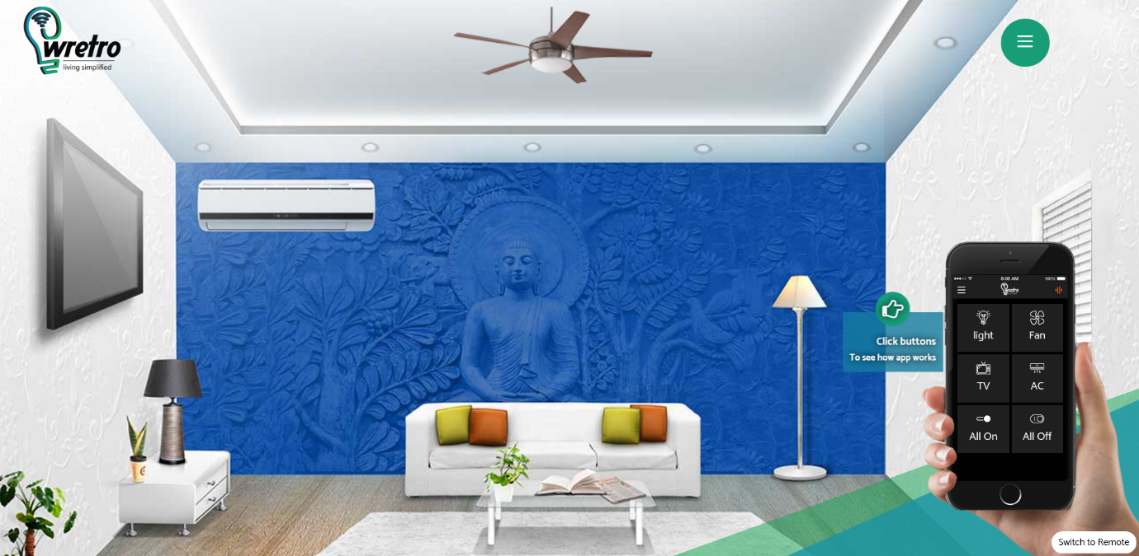

**Lights Are ON**

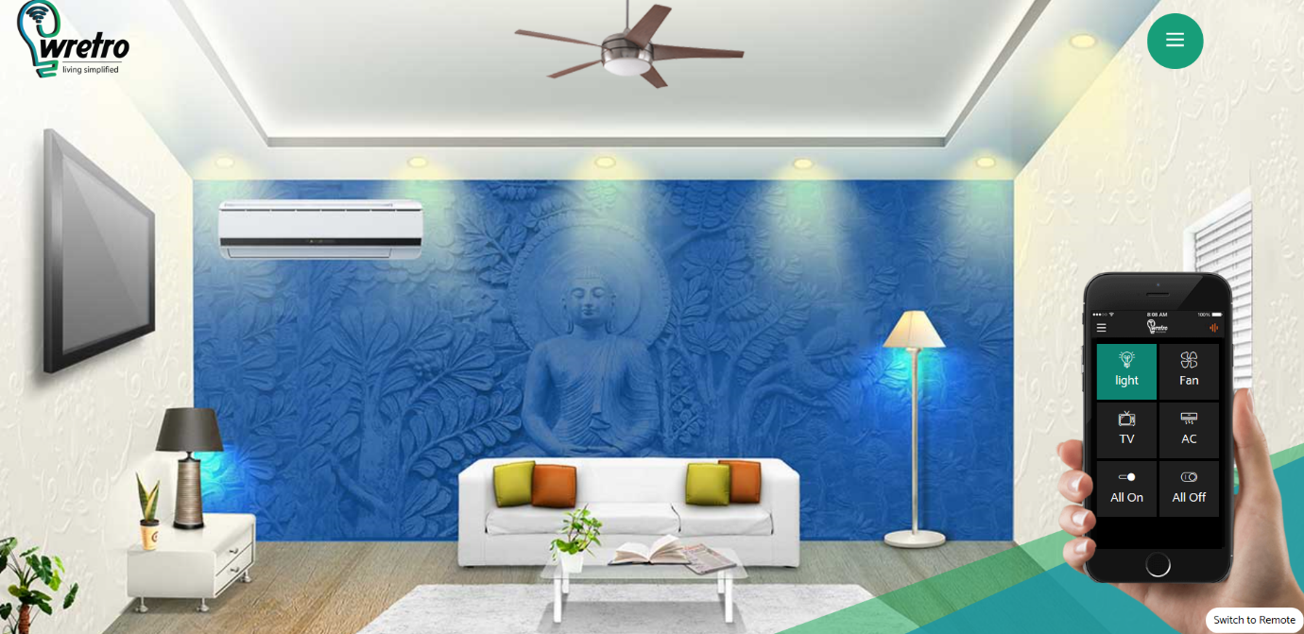

**Lights, TV, AC Are ON**

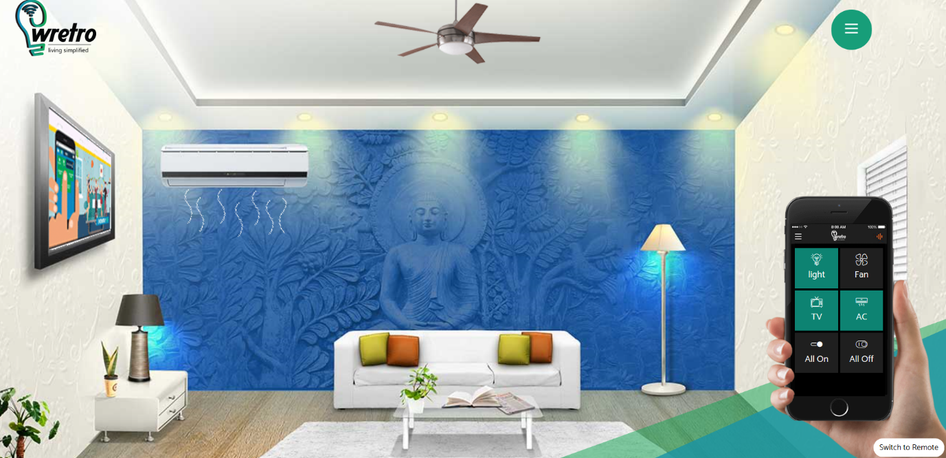

**All Are ON**

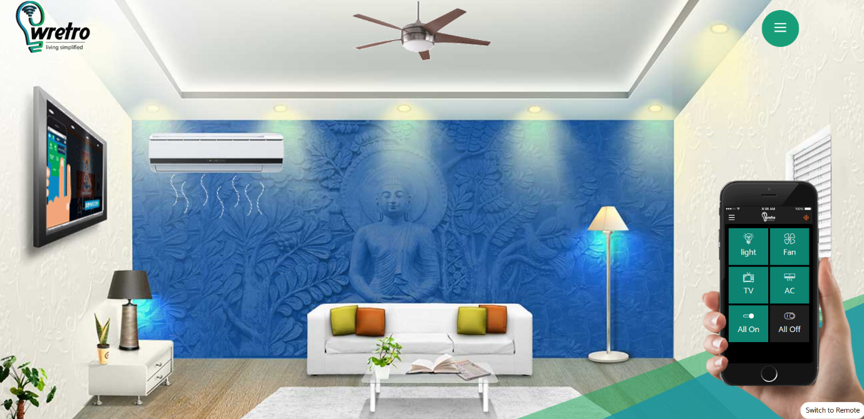

**Conclusion :**

To me personally, the connected home is every boy’s fantasy… the physical world, and more specifically one’s house reacting to your unique needs and preferences- providing a contextual, relevant and a very targeted experience. What seemed like a pipe dream is now becoming a very tangible reality; largely thanks to hardware becoming more affordable, wireless connectivity ubiquitous, and applications and their business logic platform available and open.

However, despite Alexa can controll the flow of music in the entire house or having the ability to open garage door and the main door in house through phone…I am not a very satisfied of “Home Automation” yet. It is cool, it is leaps and bounds ahead of where we were a couple of years back but its just not there yet.

From a personal perspective what really gets me excited is when plants text that they need to be watered.… house tweets whenever there is a knock on the door, along with a photograph of the person at the door (for my records). Its a fascinating world that we are beginning to be a part of and we are just starting to scratch the surface.

AI, ML, [IoT](https://sachmahajan.wordpress.com/2014/02/05/sachin-mahajan-director-telus-toronto-iot-telus-toronto-2/), [Big Data](https://medium.com/@Sachin.Mahajan/iot-nudges-big-data-into-disillusionment-2398927de2ad#.qb1gqz941)…when they come together not only will we have more iconic products but ***real iconic experiences***, and that’s what I hope the future of home automation is.

**Title of visited project:**

**2. Dahua Under Vehicle Surveillance System**

**Views on project:**

An **under-vehicle inspection** system generally consists of imaging systems mounted on a roadway and used at facility access points, particularly at secure facilities. An under-vehicle inspection system is used to detect threats—such as bombs—that are hidden underneath vehicles. Cameras capture images of the undercarriage of the vehicle for manual or automated visual inspection by security personnel or systems.

The first under-vehicle inspection system was developed in the late 1980s as part of a joint program between the [UK Home Office](https://en.wikipedia.org/wiki/UK_Home_Office) and Morfax (now a part of the [Chemring Group](https://en.wikipedia.org/wiki/Chemring_Group)). The system used black and white images from area scan cameras. The systems have since developed encompassing more advanced technologies such as database capabilities in 1994, ANPR vehicle recognition in 1997, automatic change detection in 1999, colour imagery in 2005, and integrated chemical detection in 2012.

Under-vehicle inspection systems can be permanent (embedded in the road), fixed (attached to the road's surface) or portable (mobile).

Under [vehicle inspection](https://en.wikipedia.org/wiki/Vehicle_inspection) systems are known by the acronyms UVI (under-vehicle inspection), UVIS (under-vehicle inspection systems), AUVIS (automated under-vehicle inspection systems), MUVIS (mobile under-vehicle inspection systems), and UVSS (under vehicle surveillance system). The terms UVSS and CUVSS (colour under vehicle surveillance system) were trademarks of the Chemring Group until the rebranding of the Home Office project in 2011.

**Project 2:**

**Dahua Under Vehicle Surveillance System**

**Key Feature**

.Clear and Sharp Imaging

. 2K high deﬁnition image

• Industrial level line scan camera provides real color image

**High Eﬃciency**

• Simple and quick to deploy

.Scan up to 10 vehicles per minute operated by one person

**Full Integration**

• ANPR camera management on the UVSS client

• Able to integrate with entrance management system

**Intuitive Use**

• Plug & play

• Easy to use and maintain Database Reference • All data stored locally

• Advanced report and export capabilitie

**System Overview:**

An Under Vehicle Surveillance System is used to capture images of a vehicle’s undercarriage while in motion. Security workers examine the captured images in real time and perform comparisons to prevent concealed weapons and contraband from entering or exiting secured compounds or restricted areas. In ﬁxed applications where land can be dug up for installation, such as at prisons, embassies, and borders, the Dahua stationary UVSS solution (DH-MV-VBF5020CE-00) is an ideal option. At checkpoints and installations where roads cannot to be dug up or in situations where portability is needed and temporary checkpoints are required to be moved, such as at important conference centers, temporary bases, and bridge checkpoints, the Dahua portable UVSS (DH-MV-VDM5021CE-00) allows for mobile automatic vehicle undercarriage inspection. These two under vehicle surveillance systems are able to integrate an ANPR camera and retrieve undercarriage images via plate number, and compatible with other access control systems: barrier, cats claw, bollards, and other road blocks**.**

**Image Details:**

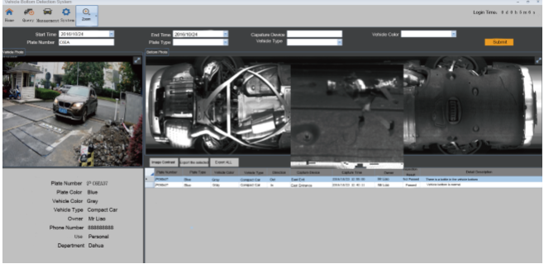

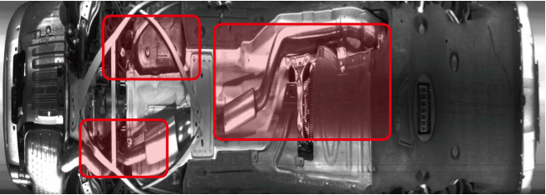

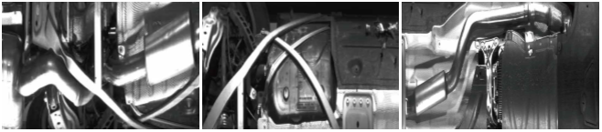

**Dahua Stationary UVSS**

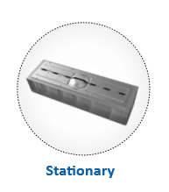

**System Components:**

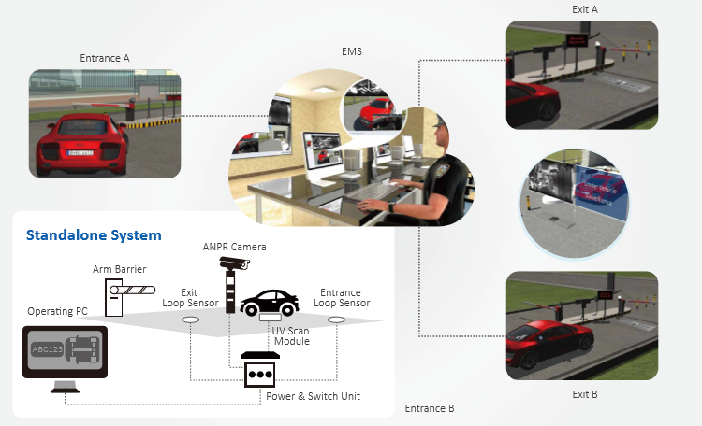

The stationary Under Vehicle Surveillance System consists of four parts: under vehicle scanning module, Automatic Number Plate Recognition camera, power supply system, and system control module. The scanningmodule provides real-time under vehicle imaging while the ANPR camera engages in license plate recognition. PC-based software with an easy-to-use GUI provides linear image stitching and information indexing for easy review. In installations with only one access point, the standalone system is the best choice. However, if there are several entrances and exits, a centralized control system integrated into EMS (Entrance Management System) is recommended to achieve multi-point surveillance and centralized control.

**Applications:**

Prevent dangerous objects hidden under vehicles from getting into prisons, airports, military bases, banks, government buildings, borders, hotel entrances, warehouses, and other important places with high security levels.

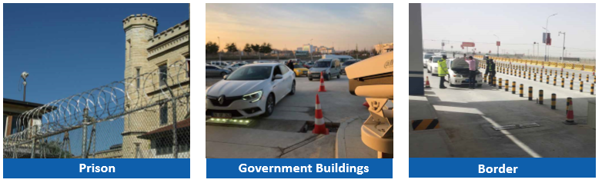

**Dahua Portable UVSS**

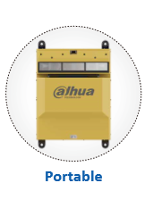

The system consists of one portable scan unit and one control platform. The scan unit includes a high resolution line scan camera with low-distortion ﬁsheye lens, two photoelectric position triggers, and long-life LED array lights. Combined with Dahua advanced distortion correction algorithms, the camera system provides a clear and sharp undercarriage image without distortion regardless of lighting conditions after automatically detecting and incoming vehicle. The scan unit is equipped with IP66 protection, making it compatible with most harsh environments. The control platform is comprised of three components: an industrial grade PC, 21”monitor, and power and switch devices. The PC integrates with the UVSS client to stitch together the scanned line image and then output a high resolution picture. In addition, the system supports connecting an ANPR camera to detect and capture license plates. License plates can then be paired together with their corresponding undercarriage image for retrieval and comparison. Finally, the control platform ﬁts nicely into a portable aviation case, making it easy to set up and ready to use in minutes.

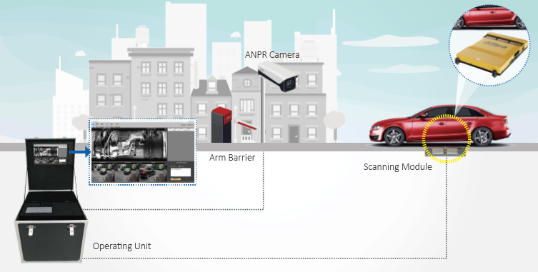

**Applications:**

The Dahua portable Under Vehicle Surveillance System, DH-MV-VDM5021CE-00 is the best choice for vehicle undercarriage inspection in the following scenarios:

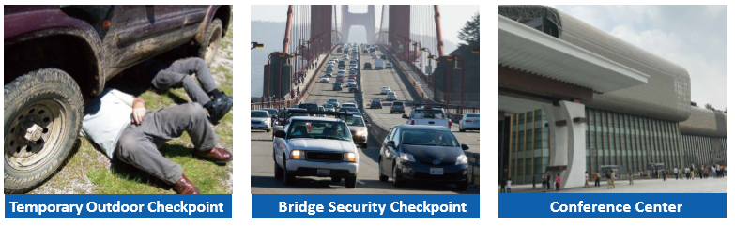

**Scope of Project:**

world really more prone to violence now than in the past, or has the Internet simply brought it into focus and spread awareness like never before? Undoubtedly, at a minimum, perceived risks are firmly implanted in the consciousness of everyday citizens, disturbing their sense of well-being and safety. Potential threats are evident with security screenings everywhere from the schoolyard to the airport, and managing security risks has become the new reality in many communities across the globe.

**Conclusion :**

I think Under Vehicle Surveillance System useful.  In many places Such as Government places, in Malls, in big shops, it is very useful. These type of cameras are very cheap and can be installed easily.

It can be very useful in crowded places. Also Big cities like Mumbai and Delhi It can be useful as they are targeted by terrorists. Big incidences like these can be avoided.